Junior Newsletter
November 2018
Almost halfway through your junior year, and although it may seem like a long, long way to graduation, there is plenty you need to be thinking about getting done this year. From studying hard for good grades to taking the first round of college admission tests to completing your junior project, there is lots to work on in the next few months.

For those who took the PSAT on October 10, your scores will be available online at www.collegeboard.org in December—if you gave them your email address, you will get an email informing you when they are ready.. You will need to create a College Board account and go to the score reporting portal. If they require an access code, it is written on the back of the PSAT test booklet you will receive with your scores. Your scores, college benchmarks, and the breakdown of which questions you answered correctly and which you did not are all available in your score reports.
The PSAT has also partnered with www.khanacademy.com to provide free individualized SAT preparation. The directions to link the PSAT with Khan are on the college board website. You can also register for one of the spring SAT dates through your account at the College Board. You can register for the ACT at http://www.act.org
The PSAT compared to the preACT many of you took last year can also help to direct you on your decision about which test might be the best for you. If you want more information on this, come and see me. Most colleges accept both tests, but many students do better on one or the other, so being able to spend your time and money on the test that you are best suited for is wise.
Taking your first SAT or ACT the spring of your junior year is especially important if you want to apply to those schools with an early action deadline of November 1. University of Maryland, College Park, is one, as is the University of Virginia and Virginia Tech. Many other schools have their early action deadline in November as well. If you are really interested in one of those schools, taking the SAT or ACT in early spring and then again in June (or August for SAT) will help you avoid the last minute

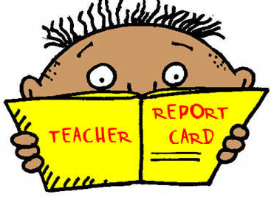
Don’t let dropping grades cause you problems! Keep your grades high and keep studying! Remember that for your college applications next fall, your junior grades will be the last ones on your transcripts when applications are submitted. Colleges want to see an upward trend in grades—if you had a rocky start in your freshman year, you can make it up with good grades this year.

This Photo by Unknown Author is licensed under CC BY-NC-SA

It’s also time to think ahead to summer—there are many options, including internships, summer college classes, volunteer opportunities, etc. What you choose can have an impact on future career and educational opportunities. Check out the many options for summer on the guidance page of the Holly Grove website.

HGCS Service Hours Requirement:
You need 20 hours of service per year attending HGCS High School. If you do not have around 60 hours of service so far, this would be a good time to get going—there are lots of opportunities in the spring and summer to get involved. Don’t forget to get the forms filled out and signed. They can be downloaded on our website.

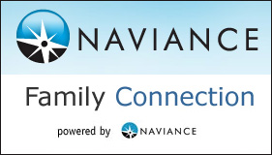
Your junior project should be underway by now—remember it is worth 200 points on your English grade! It also prepares you for next year’s application process, making it easier for you to know what you have to do those busy first months of senior year. If you have lost your Naviance sign-in info or directions, see me soon.

